**Version Control with Git**

19th June

* Practical 1: To understand the concept of version control, its importance in managing project changes, and explore different version control system.

Installation

git --version

* Practical 2: To set up git on a windows system configure git for the first time and understand the basic configuration options.

A. Install git on windows and verify the installation.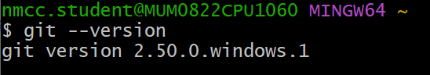

B. Configure git with your username, email and default editor.

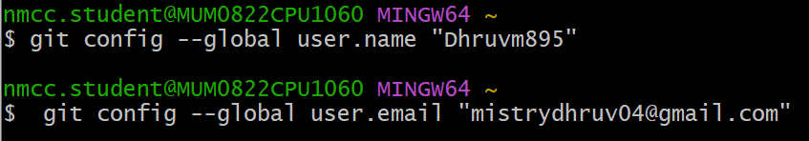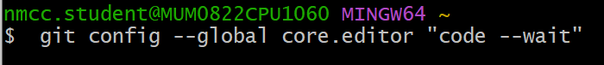

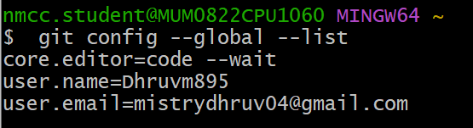

C. Explore and understand the .gitconfig file.

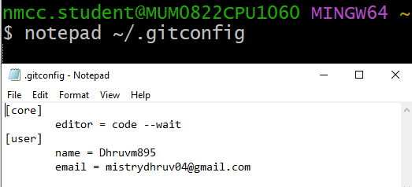

* Practical 3: To explore Github as a cloud-based hosting platform for Git repositories and understand it’s features and benefits for collaboration and project management.

A. Creating a Github account.

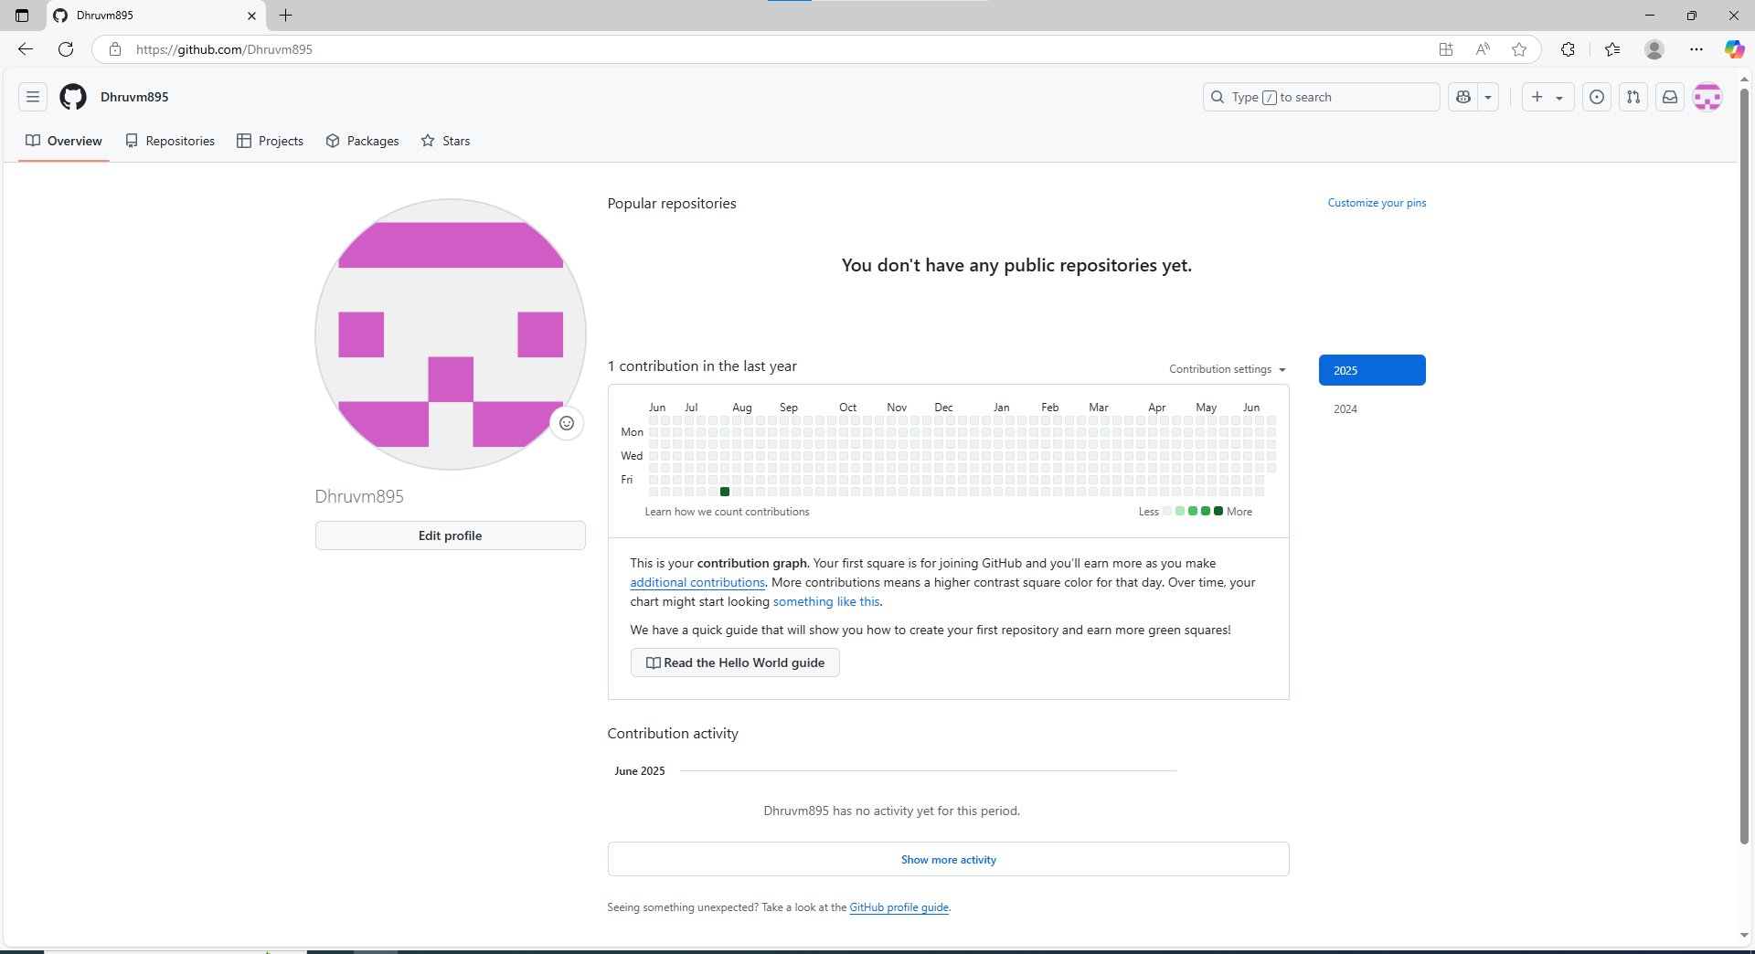

B. Generate and SSH keys to Github. 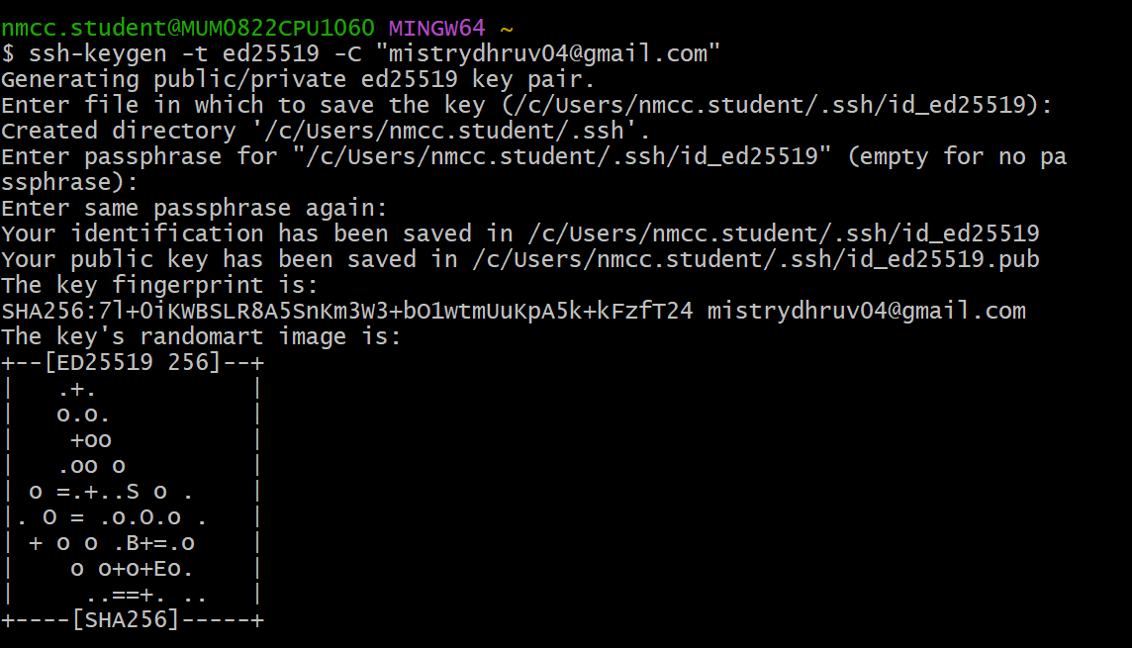

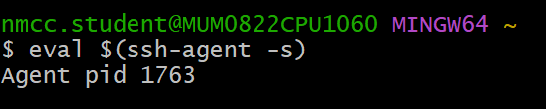





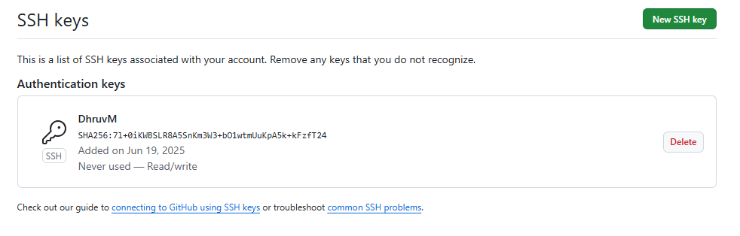



26th June

* Practical 4: To understand the concept of a Git repository and learn to create and initialize a new local repository for tracking project files.

1. Create a new local repository using git init.  
   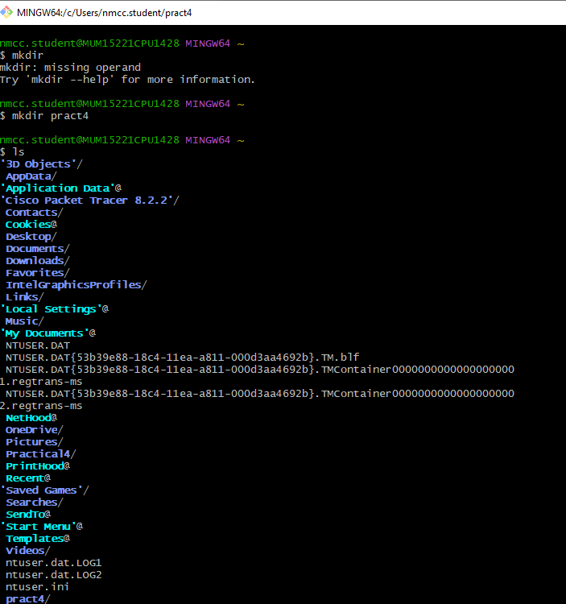

1. Initialize the Git Repository

-This creates a hidden .git folder, which contains the repository history and configuration.

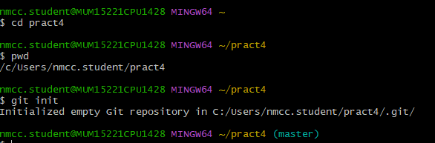

2. Add and commit files

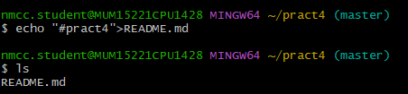

3. Add the file to staging

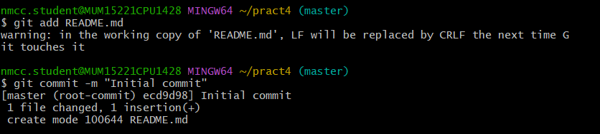

1. Clone an existing remote repository using git clone.

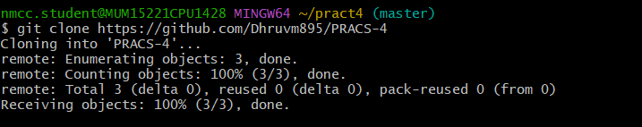

1. Compare the structure of a local and remote repository.

1. Local Repository (git init)

-Exists only on your computer

-Contains a .git folder for version control

- Does not have a connection to a remote repository unless

added later (git remote add origin <URL>).

2. Remote Repository (git clone)

-Hosted on platform like GitHub

- Can be accessed by multiple uses.

- Already has a .git structure and commit history.

- The cloned local copy automatically tracks the remote repository.

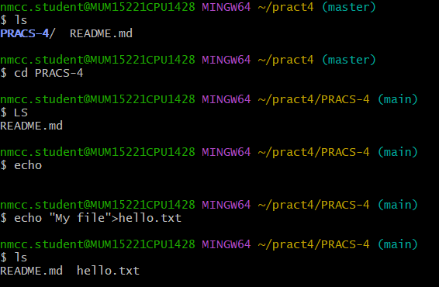

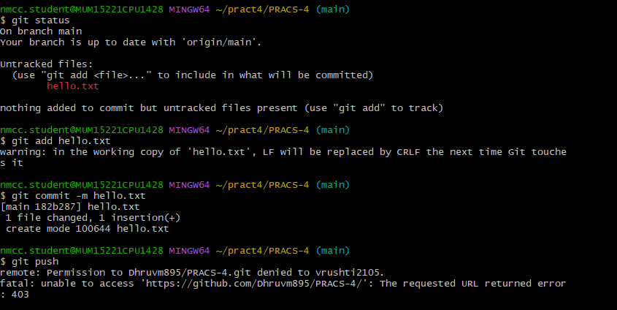

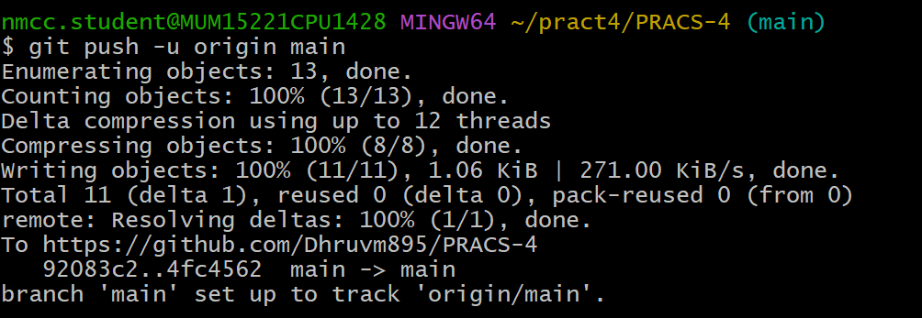

* Practical 5: To practice recording changes to files in a Git repository, checking file statuses, and managing tracked and untracked files.